
Name: Abdul Samad
Program: BSSE Group A
Semester: 5th
Date: October 06, 2026
*-----------------------------------------------*

Lab Task 6

Name: Abdul Samad

Program: BSSE Group A

Task 05

Design subnets.
An organization has:
192.168.50.0/24
It needs:
Department | Hosts Required
Data Science | 40
Administration | 18
Faculty | 28
Management | 13
Determine a suitable prefix and subnet mask for each. Then assign address ranges.
Department | Prefix | Mask | Network | Host Range | Broadcast
Data Science | /26 | 255.255.255.192 | 192.168.50.0 | 192.168.50.1 –  192.168.50.62 | 192.168.50.63
Administration | /27 | 255.255.255.224 | 192.168.50.64 | 192.168.50.65 –  192.168.50.94 | 192.168.50.95
Faculty | /27 | 255.255.255.224 | 192.168.50.96 | 192.168.50.97 –  192.168.50.126 | 192.168.50.127
Management | /28 | 255.255.255.240 | 192.168.50.128 | 192.168.50.129 –  192.168.50.142 | 192.168.50.143

Subnetting Challenge
You are given:
192.168.10.0/24
The organization requires:
- Network A → 100 hosts
- Network B → 50 hosts
- Network C → 20 hosts
- Network D → 10 hosts
Design an appropriate addressing plan. Students must determine:
- Prefix
- Subnet mask
- Network address
- First usable host
- Last usable host
- Broadcast address
Network | Prefix | Subnet Mask | Network Address | First Usable Host | Last Usable Host | Broadcast Address
A (100) | /25 | 255.255.255.128 | 192.168.10.0 | 192.168.10.1 | 192.168.10.126 | 192.168.10.127
B (50) | /26 | 255.255.255.192 | 192.168.10.128 | 192.168.10.129 | 192.168.10.190 | 192.168.10.191
C (20) | /27 | 255.255.255.224 | 192.168.10.192 | 192.168.10.193 | 192.168.10.222 | 192.168.10.223
D (10) | /28 | 255.255.255.240 | 192.168.10.224 | 192.168.10.225 | 192.168.10.238 | 192.168.10.239

*-----------------------------------------------*
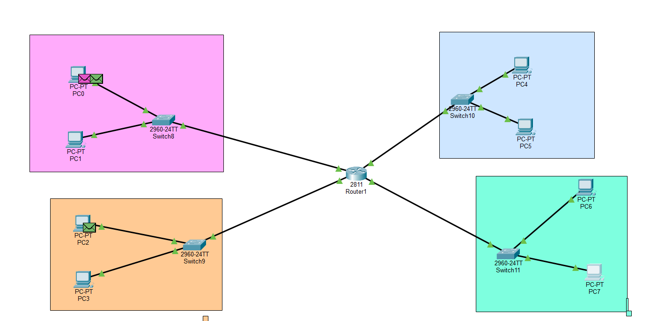
*-----------------------------------------------*

The End

